**7-1 Final Project Reflection**

**Development Choices**

The first object I created was the table by using a plane. To create a pencil, I used the shapes hexagon/nonsmoothed out cylinder and a pyramid. The hexagon/cylinder was used for the pencil length, metal, and eraser while the pyramid was used for the tip of the pencil. The next object I created was a paint tray. The paint tray was created by using planes. The paint brush was created by using two cubes and one pyramid. Finally, the last object I created was a canvas.

To texture the plane, pencil, and paint tray, I created a word document and pasted in multiple images to create the texture I was aiming for. For further clarification, I took a screenshot of a pencil tip, added it into the word document, took a screenshot of the metal part of a pencil, added that in, etc.. Once they were all added, I saved all the separate images together to create my texture. Once this image was imported into my code folder, I was able to establish the texture coordinates and have each separate part of the image attach to the correct shapes and/or part of the shapes.

While creating the vertices for each of these objects, it was extremely important to have well commented codes; such as “//left side front point”. Having well commented code made it easier to go back and make changes, add texture, add lighting, and more due to knowing what each line did.

**Navigation**

Navigating within my scene is fairly simple. One of the main source of movement is from the keyboard. The keys that invoke movement are: the ‘W’ key moves forward, the ‘A’ key moves to the left, the ‘S’ key moves backwards, the ‘D’ key moves to the right, the ‘Q’ key moves upwards, and the ‘E’ key moves downwards. Other forms of movement are from the mouse cursor and mouse scroll. The mouse cursor will allow you to look around the scene by moving the objects, while the mouse scroll will adjust the speed of said movement. To avoid any part of the object to be overly dark, I included a spot light that will ‘move’ with the camera.

**Custom Functions**

This code is, for the most part, reusable. For simplicity sake, I kept certain code actions together; such as the code for camera movement. If you wished to reuse the camera movement, you would want to copy the ‘camera.h’ header file. In addition, to process the keyboard input queries, you would want to copy from line 644 to 661. These input commands can also be customized to the keys and functions you wish to complete with a keyboard. To reuse the mouse movement, you will want to copy from line 674 to 697. Overall, there are comments in each section to help increase the readability – which then helps both the viewer and the programmer to further understand what the thought process was when completing the assignment.

My reference picture for the scene: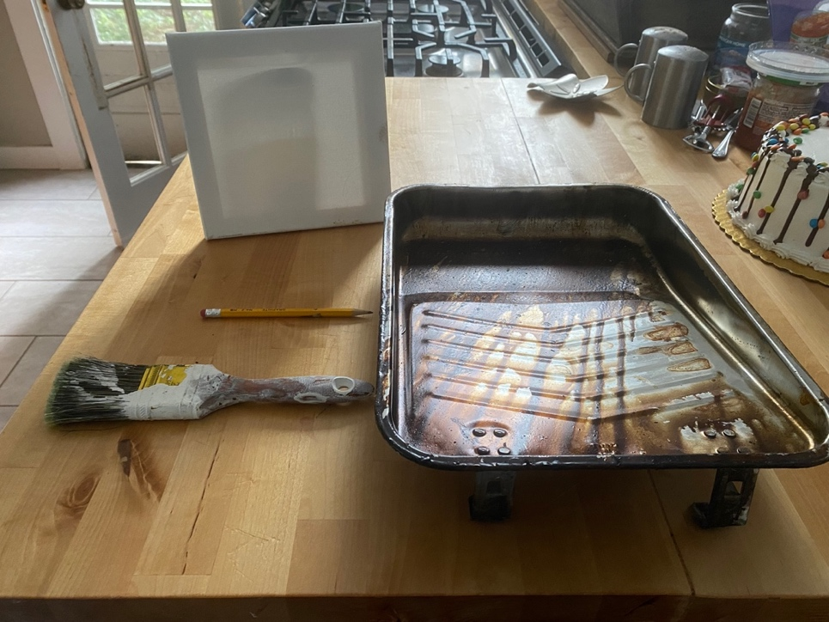

My 3D Scene:

